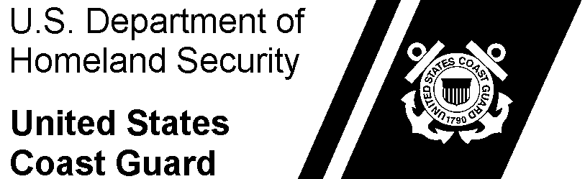 | Commanding Officer  USCGC ATLANTIC | 100 Munroe Drive  Norfolk, VA, 23324  Phone: (123) 456-7890  Email: Gregory.j.logan@uscg.mil

4061
01 May 2020
MEMORANDUM
From: | G. J. Logan, CS2
To: | (commanding officer)  USCGC ATLANTIC
Subj: | RELIEF OF FOOD SERVICE OFFICER
Ref: | - Food Service Manual COMDTINST M4061.5A (series)  - Coast Guard Food Service Practical Handbook COMDTPUB P4061.4  - Food Safety and Sanitation Program Tactics, Techniques, and Procedures (TTP)
- In accordance with reference (a), a joint complete physical inventory was conducted on 30 April 2020. Verifying the count and total dollar value of subsistence items in stock. Prices were reviewed, and no discrepancies were noted. The total dollar amount of subsistence items listed on the Provision Inventory Report (CG-4261) and the Dining Facility Operating Statement (CG-2576) is $520.00 on 30 April 2020.
- Accounts receivable is in good standing. There are receivables to be collected by the CGDF in the amount of $208.20. The Account Status Detail Report (ASDR) indicated no balances past due and no surplus balances on account.
- A FINCEN XS6 purchase recon was completed on 14 January 2019. All purchase adjustments claimed on the February 2019 CGDF Operating Statement as per FINCEN guidance. (Contact FINCEN to verify).
- All subsistence invoices are paid to date.
- The dining facility currently has an unused allowance of $98.17.
- The Coast Guard Dining Facility records have no discrepancies at this time
- The last required Annual Audit Verification was completed on 17 November 2019.
- The last FSAT visit was completed on 03 August 2019.
- The stack oven is out-of-commission with repairs being effected. The ice machine is out-of-commission until further notice.
- All food service preparation areas, dining areas, and scullery’s are in good/sanitary condition in accordance with reference (c).
- I am familiar with and understand my duties and responsibilities as outlines in reference (a).
- As of 01 May 2020, I, Gregory J. Logan request permission to relieve (old FSO) of all duties as FSO onboard USCGC ATLANTIC.
#

Enclosure: |  | - Dining Facility Operating Statement (CG-2576)  - Provision Inventory Report (CG-4261)  - FSO Designation Memorandum  - Supply Fund Report (SFR)
Copy: | HSWLSC Subsistence Product Line (SPL)  FINCEN (OGD)  FORCECOM (FC-Acfsat)

