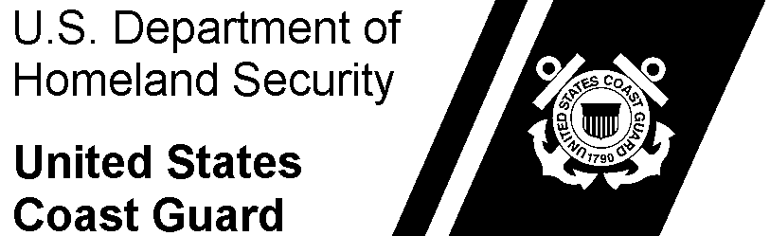 | Commanding Officer  USCGC PACIFIC | USCGC Pacific  100 Coast Guard Way, Petaluma, CA, 94952  Phone: (123) 456-7890

4061
01 Apr 2020
MEMORANDUM
From: | G. J. Logan, CS2
To: | (commanding officer)
Subj: | RELIEF OF FOOD SERVICE OFFICER
Ref: | - Food Service Manual COMDTINST M4061.5A (series)  - Coast Guard Food Service Practical Handbook COMDTPUB P4061.4  - Food Safety and Sanitation Program Tactics, Techniques, and Procedures (TTP)
- In accordance with reference (a), a joint complete physical inventory was conducted on 31 March 2020. Verifying the count and total dollar value of subsistence items in stock. Prices were reviewed, and no discrepancies were noted. The total dollar amount of subsistence items listed on the Provision Inventory Report (CG-4261) and the Dining Facility Operating Statement (CG-2576) is $325.00 as of 31 March 2020.
- Accounts receivable is in good standing. There are receivables to be collected by the CGDF in the amount of $241.20. The Account Status Detail Report (ASDR) indicated no balances past due and no surplus balances on account.
- A FINCEN XS6 purchase recon was completed on 25 February 2019. All purchase adjustments claimed on the March 2019 CGDF Operating Statement as per FINCEN guidance. (Contact FINCEN to verify).
- All subsistence invoices are paid to date.
- The dining facility currently has an unused allowance of $356.90.
- The Coast Guard Dining Facility records have no discrepancies at this time.
- The last required Annual Audit Verification was completed on 31 January 2020.
- The last FSAT visit was completed on 24 October 2019.
- All food service tools and equipment are in good condition and/or operating properly in accordance with reference (b).
- All food service preparation areas, dining areas, and scullery’s are in good/sanitary condition in accordance with reference (c).
- I am familiar with and understand my duties and responsibilities as outlines in reference (a).
- As of 01 April 2020, I, Gregory J. Logan request permission to relieve (old FSO) of all duties as FSO onboard USCGC Pacific.
#

Enclosure: |  | - Dining Facility Operating Statement (CG-2576)  - Provision Inventory Report (CG-4261)  - FSO Designation Memorandum  - Supply Fund Report (SFR)
Copy: | HSWLSC Subsistence Product Line (SPL)  FINCEN (OGD)  FORCECOM (FC-Acfsat)

