UNITED STATES COAST GUARD
MARCUS HANNA (WLM-554)

UNIT INFORMATION:
For Incoming Personnel
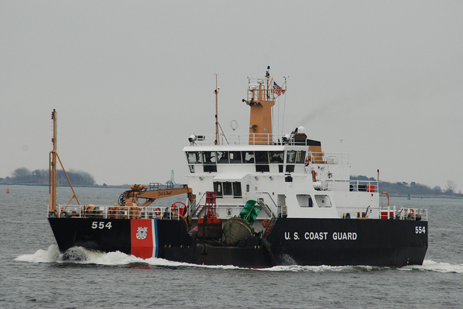

Congratulations on receiving orders to the Coast Guard Cutter Marcus Hanna (WLM 554). The following is a brief overview of some key information that will be helpful to know in becoming familiar with the area. If you have any questions that are not answered here, let your sponsor know. We’re looking forward to having you as a part of the crew. Welcome Aboard!

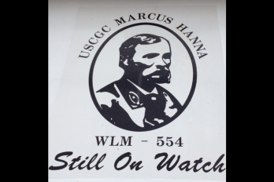

COMMAND CADRE

Commanding Officer: CWO2 Gregory Shriver

Executive Petty Officer: BMCS Laufenberg

Engineering Petty Officer: MKCS Wilkenson

Operations Petty Officer: BM1 Phillips

1st LT: BM1 Bowell

Co-Located Units: MSU South Portland District: 1 Sector: Northern New England
Station South Portland
Aids To Navigation Team South Portland
Coast Guard Cutter Shackle

Phone: (207) 767-0380 Cell: (207) 751-9377 Fax: (207) 767-0384

Mailing And Physical Address: USCGC Marcus Hanna (WLM-554)
259 High Street
South Portland, ME 04106

WELCOME ABOARD PACKAGES AND YOUR SPONSOR
A welcome aboard message from your sponsor will be sent after we receive
notification of PCS. If you have not heard from your sponsor or the Cutter in a reasonable
amount of time after receiving orders, you are encouraged to contact the Cutter. If you
call after hours or on a day when your sponsor is not present ask to speak with the Command Duty Officer. Also, the watch stander will be taking down your information so that we can make preparations for your arrival in which you should have the following items available before calling: your leave address, cell phone number, dependents information, mode of travel, dates/times of places you’ll be between transfer, and whether you plan to take leave.

Is it Advisable to Bring Dependents Along When Reporting?

New personnel are encouraged to transfer their families with them to the area; however, when initially checking into the unit, it is advised if possible to find local housing prior or contacting the sector housing officer, June Ludwith at (207) 780-3071. Please do not bring family members onboard until check-in process is complete.

CUTTER OPERATIONS

Unit Missions:

Aids To Navigation and Search And Rescue Standby

Typical SA/SN Qualifications:

In port watch stander, Helm and Lookout, Buoy Deck Rigger, SEOPS and Torch Operator.

Rates at Unit:

BM, MK, CS, EM, ET, SK and DC

Typical Qualifications:

In Port Watch Stander, Helm and Lookout, Engineer of the Watch, Buoy Deck Rigger, SEOPS, Torch Operator, Crane Operator, Command Duty Officer, Buoy Deck Supervisor, Junior Officer Of The Deck, Officer Of The Deck, Coxswain, and Boat Crewman.

Work Schedule:

In port: Monday thru Friday: 0715 to 1300

Underway: Generally M-F, but operations and weather may impact it.

Galley Hours
Breakfast: 0645-0715
Lunch: 1300 in port 1100 underway
Dinner: 1700-1730 In port open Galley after hours

How much personal storage space:

Each member is given one locker to store their buoy deck gear, one locker and rack space for uniforms and personal items.

Uniforms when reporting to unit:

From November 1st to March 31st -Service Dress Blue

From April 1st to October 31st – Tropical Blue

Uniform Of The Day:

Operational Dress Uniform

Area Of Responsibility:

Covering Aids to navigation from Weymouth, MA to Damariscotta, ME. We also cover the Sheepscot, Kennebec and Piscataqua Rivers. We are a primary unit to roughly 380 Federal Floating Aids to Navigation.

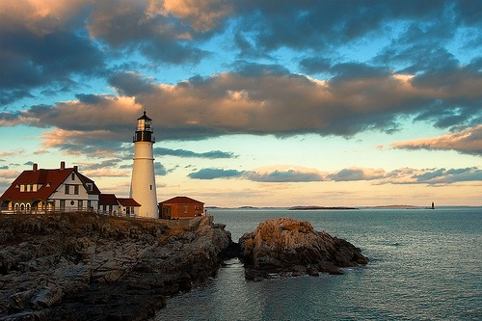

PERSONAL ITEMS

Unit Mutual Assistance Rep

BMCS Laufenberg: 207-767-0380

Housing Information

All members E-4 and above and also members with dependents E-3 and below are entitled to BAH. There is privateer housing available in Brunswick which is 25 mi north. Privateer housing is limited so make sure to go through housing officer prior to reporting. All single members E-3 and below live in the barracks on base and also limited UPH housing to a couple of the members onboard as well.

Cutter personnel live throughout the greater Portland area which includes:

Portland (in town)
South Portland
Westbrook
Gorham
Scarborough
Windham
Yarmouth
Brunswick

2017 BAH RATES

E-3/4 w/ dep= $ 1794
E-3/4 without dep = $1347
E-5 w/ dep = $ 1965
E-5 without dep = $ 1506
E-6 w/ dep = $ 2265
E-6 without dep = $ 1698

http://www.defensetravel.dod.mil/site/bah.cfm

Average 1 bedroom = $ 900-1200

It is strongly recommended to live within 30 minutes of the unit

Housing Office: June Ledwith, 207-780-3074 or Steve Perrier 207-780-3071

AROUND THE AREA

Average Temperature

Summer – 80 degrees winter – 25 degrees

Snowfall Annual – 70” - 80”

Location of Nearest Exchange

There is a Coast Guard Exchange nearby in South Portland. There are no commissaries within the local area.

Religious Denominations in the Area

Many denominations located throughout the Greater Portland area. There is also a Coast Guard Chaplin located in Sector Northern New England.

Grocery Stores

Within driving distance from base are multiple Hannaford’s, Shaw’s, Whole Food’s and Trader Joe’s.

Where do Most People Bank

There is no short supply of banks or credit unions. Most people prefer to use USAA, Bank of America or Bangor Savings Bank.

Shopping in the Area

Maine Mall is an average sized mall with any store you need, as well as numerous outlet stores located 30 minutes north in Freeport.

Continuing Education in the Area

University of Southern Maine and Southern Maine Community College are both located in Portland and South Portland.

MEDICAL

What level of Tricare is available

Tricare Prime Remote

Dental

Most members go to Gentle Dental or Aspen Dental. Both offices except Tricare.

Recreation in the area

There are minor league hockey, baseball and basketball teams in Portland. Plenty of live music. There are a few summer festivals held in the area as well as a few nice beaches. Boston is a short drive away, roughly an hour and half south. Many members enjoy skiing and snowboarding nearby as well as hunting and fishing.

