by P1ch3

-In memory of our good friend, and CORE OG, jonjo ✝️

CORE TYPE R is a “cream of the crop” build by the CORE TEAM’s master artist, P1ch3.
P1ch3’s intention with Type R, was to create a build with only the best of the best hand selected games for only the best systems, with beautiful and complete art, whilst still being able to download to, and extract on a 500gb hard drive.
Once again using RetroFE as the front end of choice, TYPE R is packaged with an updated version of P1ch3’s very own “TITAN” theme.
Every inch of effort has been taken to ensure only the best, complete art assets have been added, to compliment P1ch3’s amazing TITAN theme. From logo’s, covers, bezels & videos being remade by the thousands, to thousands of fanarts being sourced, edited or made from scratch. No stone has been left unturned to make this build look amazing in all of the MANY menu layout options included.

Thanks\credits go to the following:
- All of the CORE Team and helpers, special mentions to Signum, VIEIRA & STAiNLESS for the hands on help. Also Htaed7 RCT for keeping an on things.
- Signum again for making the awesome menu videos.
- All of the CORE discord members, this is all done for you guys.
- RetroFE community, creators and devs.
- Enkak for some crucial shader help.
- The numerous emulator devs (too many to list), we all appreciate what you guys are doing.
- Emumovies and Launchbox contributors. Amazing resources for retro gaming art.
- Skraper team, another amazing resource for art.
- Duimon for some fantastic bezel art.
- The Bezel Project for their MAME bezels.

If you have not done so already, please join us on CORE Discord
TYPE R Menu Controls:
TYPE R and all included systems\emulators has been configured to work out of the box with genuine Microsoft XBOX 360\ONE controllers.

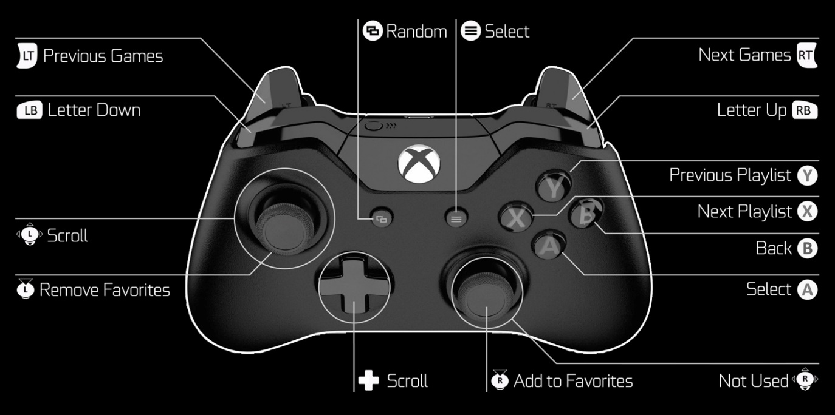

In-Game Controls:
- To close a game and return to the TYPE R menu, press \ + \
- To access RetroArch or MAME menu’s, load a game then press  + 
Settings:
As TYPE R has been built for absolute eyecandy front to back, where possible, the included systems have been upscaled to 1080p.
If you are having performance issues due to weaker hardware, you may need to scale this back a bit. If needed, ask for assistance on CORE Discord.
Disclaimer:
It is CORE devs wishes that Type R, or any part of shall not be modified, repackaged or distributed by others without their full consent.

For all additional help, support & updates, please join us on CORE Discord

